**Dr. J. J. Magdum Trust’s**

**Dr. J. J. Magdum College of Engineering, Jaysingpur – 416 101**



# REPORT ON DOMAIN SPECIFIC MINI PROJECT

**DEPARTMENT OF COMPUTER SCIENCE & ENGINEERING.**

**Shivaji University, Kolhapur**

**Academic year: 2023-2024**

**A**

**Domain-Specific Mini Project Report**

**On**

**Personal Finance Management Dashboard**

Submitted By

**Name Roll No.**

* **Srusti Chalke 04**
* **Abdulfaiz Shaikh 49**
* **Aryan Shinde 52**
* **Gayatri Suryawanshi 54**

**Under the guidance of**

**Prof. N. H. Sayyad**

Department of Computer Science & Engineering.

**Dr. J. J. Magdum College of Engineering,**

**Jaysingpur.**

**Dr. J. J. Magdum Trust’s**

**Dr. J. J. Magdum College of Engineering, Jaysingpur – 416 101**

## Department of Computer Science & Engineering

**CERTIFICATE**

**This is to certify that the project work entitled**

**Personal Finance Management Dashboard**

submitted by

###### Name Roll No.

###### Srusti Chalke 04

###### Abdulfaiz Shaikh 49

###### Aryan Shinde 52

###### Gayatri Suryawanshi 54

**in fulfillment of requirement for the semester II of Third Year in Computer Science & Engineering. This is a record of their work carried out by them under supervision and guidance during academic year 2023-24**

Prof. N. H. Sayyad DR. D. A. Nikam

Project Guide H.O.D. CSE Dept.

DR. S.B.Patil

Principal External Examiner

**ACKNOWLEDGEMENT**

First of all, we would like to thank Prof. N. H. Sayyad who is presently working as a professor of Computer Science and Engineering Department for guiding us through this project work. We are extremely grateful to her for all her invaluable guidance and kind suggestions during all the phases of our project work. Her ever-encouraging attitude, guidance and whole hearted help were biggest motivation for us in completing this project work.

We are thankful to the founder Chairman Late Dr. J. J. Magdum and the Chairman hon. Mr. Veejhay J. Magdum of Dr. J. J. Magdum Trust, Jaysingpur, for their encouragement. We are very grateful to Dr.S. B. Patil, Principal of Dr. J. J. Magdum College of Engineering, Jaysingpur for motivating us for this seminar/project work. Also we are thankful to Dr. D.A.Nikam, Head Department of computer science Engineering for providing the necessary facilities for the completion of this project work.

Lastly we thank all the persons who have guided and helped us directly or indirectly.

*Name of Student Signature*

*Srusti Chalke*

*Abdulfaiz Shaikh*

*Aryan Shinde*

*Gayatri Suryawanshi*

**CONTENT**

**Ch. No. Topic Page No.**

*Acknowledgement I*

*Content II*

*Abstract III*

**Chapter 1 PROBLEM STATEMENT 06**

**Chapter 2 INTRODUCTION 07**

**Chapter 3 LITERATURE REVIEW 08**

**Chapter 4 PROPOSED WORK. 09**

**Chapter 5 SYSTEM ARCHITECTURE. 10**

**Chapter 6 METHODOLOGY. 11**

**Chapter 7 FUTURE WORK 12**

**Chapter 8 REQUIREMENT AALYSIS 13**

**Chapter 9 CONCLUSIONS 14**

**REFERENCES 15**

ABSTRACT

In today’s age, financial stress is one of the leading causes of depression in most adults. In hopes of reducing this stress, we could use our technology to help manage our finances. We can manage our finances simply by keeping track of them, setting goals, investing, being financially literate. Managing finances effectively is one of the most essential habits one should have.

This habit requires accessible and insightful tools to be able to manage our money while keeping our long-term goals in mind. This project proposes the development of dynamic personal finance management dashboard – a web-based platform empowering users to gain control over their money and financial goals.

The project offers a comprehensive suite of features including:

* Real-time data visualization: Interactive charts and graphs to depict income, expenses, net worth, and spending patterns.
* Automated transaction syncing: Secure connection with financial accounts to automatically import transaction data.
* Granular expense tracking: Categorization and analysis of spending for informed budgeting and goal setting.
* Personalized budgeting tools: Customizable budgeting templates and tracking progress against financial goals.
* Goal setting and monitoring: Defining short- and long-term financial objectives and monitoring progress towards achieving them.
* Secure and user-friendly: Robust data security and a user-friendly interface for seamless navigation and customization.

By leveraging this dynamic platform, users will gain valuable insights into their financial behaviors, make informed decisions about spending and saving, and ultimately achieve greater financial independence and well-being. This project contributes to the development of innovative personal finance tools, potentially impacting personal financial literacy and fostering responsible financial decisions among users.

**PROBLEM STATEMENT**

People have trouble with spending too much, not budgeting, and not saving because they struggle with managing money.

Current tools don't help much with these problems.

We need an easy tool to track spending, make budgets, and set goals to help people manage money better and be more secure financially.

**INTRODUCTION**

Financial management is a crucial aspect of one’s life that significantly influences personal well-being and overall quality of life. Unfortunately, not everyone possesses the necessary skills or discipline to manage their finances effectively. The struggles of not managing finances can lead to a cascade of challenges, impacting various aspects of an individual’s life.

Common challenges in managing finances are widespread and often stem from various factors, including behavioral tendencies, lack of awareness, and inadequate financial education. Some of the most prevalent challenges include:

1. Overspending
2. Lack of Budgeting
3. Difficulty tracking financial goals
4. Insufficient Emergency Savings
5. Inadequate Financial Education

Addressing these challenges requires a proactive approach to financial management. This includes developing a realistic budget, setting achievable financial goals, improving financial literacy, and cultivating habits that promote responsible spending and saving.

That is where our project comes into the picture. This website has been made by keeping in mind the two aspects of user preference that are of utmost importance in Web success; usability and user satisfaction (Urvashi Tandon, 2015).

The Personal Finance Management dashboard is a centralized platform that allows user to track their financial data, set budgets, and manage their overall financial well-being. It typically provides real-time insights into income, expenses, net worth, and spending patterns, enabling users to make informed financial decisions.

Some of the key features of this Web App are:

1. Expense Tracking: The dashboard should allow users to categorize and track their expenses, providing detailed information on where their money is going.
2. Income Tracking: Users should be able to easily track their income from various sources, including salaries, freelance work, investments, and other earnings.
3. Budgeting Tools: The dashboard should offer budgeting tools to help users create and stick to their financial goals. This may include features like budget creation, expense tracking against budgets, and notifications for overspending.

Overall, a personal finance management App is an invaluable tool for anyone seeking to take control

of their finances, make informed decisions, and achieve their financial goals. It provides a centralized platform to track spending, set budgets, visualize financial data, and plan for the future.

**LITERATURE REVIEW**

### About Personal Finance

Financial stress has been proposed as an economic determinant of depression. However, there is still little systematic analysis of different dimensions of financial stress and their association with depression. However, research has found that low income, debt, and financial hardships is an indication of financial stress.

(Guan N, 2022) identified eleven studies, examining the relationship between individual or household income levels and depression. This positive association between low income and depression was reported in both high-income countries and low and middle-income countries and found in different age groups (i.e. younger adults, middle-aged adults, and older adults).

This project tries to overcome the user’s financial stress with the help of various tools such as data visualization, helping them set goals, display better stats, and financially educate them. Helping them visualize and better understand finances with research backed methods is one of the ways to overcome the financial stress.

### About Web Development

A website can be defined as a set of connected interfaces and functional attributes designed to deliver high levels of performance and usability to users (Sangwoon Lee, 2010).

With the aim of making the website user friendly, as finances are a complex aspect of modern life, we read through various research papers as reference and implemented what we thought is best practice in developing a website.

According to (Iman Dianat, 2019) two aspects of Web design had a positive effect on the usability of websites; Web layout and performance, while personal characteristics of users such as gender, age, and Web usage experience had no effect.

While visual appeal plays a part, crafting an attractive website goes beyond aesthetics. It’s about understanding intent and audience, weaving a seamless user experience, and infusing personality and trust. Striking a balance between engaging visuals and clear information hierarchy is crucial. Intuitive navigation empowers users to find what they seek effortlessly. Micro-interactions and subtle animations can add delight, while responsiveness ensures flawless across-devices display. Finally, infusing unique branding elements fosters trust and recognition. Remember, an attractive website isn’t just visually pleasing; it’s an invitation to explore, a promise of value, and an echo of your brand’s unique voice.

**PROPOSED WORK**

**Personal Finance Management Dashboard**

This project aims to develop a dynamic and user-friendly personal finance management dashboard, empowering individuals to gain control of their finances and achieve their financial goals.

**Target Users and Needs Assessment.**

* Young professionals, families, and working students.
* Income tracking, goal setting, Budgeting, Budget Tracking, User friendly Interface, Interactive Design, etc.
* Design preference: Clean and minimal.

**Features and Functionality**

* **Data Aggregation and Visualization (30%):**
  + Design interactive dashboards with real-time visualizations of income, expenses, net worth, and spending patterns (e.g., charts, graphs).
  + Allow users to customize data views and personalize their dashboard experience.
* **Budgeting and Goal Setting (30%):**
  + Implement flexible budgeting tools with various budgeting methods (e.g., 50/30/20 rule, zero-based budgeting).
  + Enable users to set and track financial goals (e.g., saving for a down payment, travel fund).
  + Provide progress reports and notifications to help users stay on track with their budget and goals.
* **Financial Analysis and Reporting (20%):**
  + Develop tools for categorization and analysis of spending habits by category, merchant, or timeframe.
  + Generate financial reports summarizing income, expenses, and net worth over various periods.
  + Allow users to download reports in different formats (e.g., PDF, CSV).
* **Security and User Experience (20%):**
  + Implement robust security measures to protect user data and financial information.
  + Design a user-friendly and intuitive interface for easy navigation and data interaction.
  + Ensure cross-platform compatibility and mobile responsiveness for seamless access on different devices.

**Technical Stack**

React.js, Material-UI, Node.js, Express, MongoDB, dcrypt.

**Development Process**

* 1. Planning (2 weeks): Requirement gathering, technology selection, Project timeline and resource allocation, Quality assurance plan.
  2. Design (2 weeks): Information architecture, visual design, usability testing.
  3. Coding (2 weeks): Frontend dev, Backend dev, Unit testing, Integration testing.
  4. Deployment (2 weeks): Choose a hosting platform, deployment and configuration, security hardening.

**SYSTEM ARCHITECTURE**

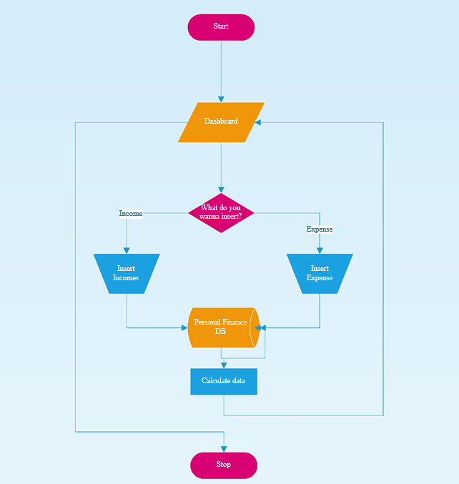

**METHODOLOGY**

Research Area: This project will examine the relationship between financial awareness (FA), specifically budgeting techniques and visualization, and financial outcomes. Financial quotient (FQ) will be considered as a potential moderator of this relationship.

Research Question: To what extent does being conscious of one's finances, through the use of budgeting techniques and visualization, contribute to improved financial outcomes? Does financial quotient moderate this relationship?

Data Collection:

* Data Source: We will analyze existing research papers and articles published in academic journals, government reports, and reputable financial institutions.
* Search Strategy: We will utilize relevant keywords and databases such as Science Direct, JSTOR, Google Scholar, and EconLit to identify studies investigating the connection between financial awareness, budgeting/visualization, FQ, and financial outcomes.
* Inclusion/Exclusion Criteria: Studies will be included if they:
  + Quantitatively measure financial awareness, budgeting/visualization, and financial outcomes.
  + Report FQ data or discuss its potential moderating role.
  + Are published in English within the past 10 years.
  + Meet quality standards regarding methodology and data analysis.
  + Exclude studies focusing solely on specific populations like students or high-income individuals.

Data Analysis:

* Software: We will employ data analysis software like R, Python, or STATA to perform quantitative analysis on the extracted data.
* Analysis Techniques:
  + Meta-analysis to synthesize findings across studies and estimate the overall effect size of financial awareness on financial outcomes.
  + Moderation analysis to examine if FQ moderates the relationship between financial awareness and financial outcomes.
  + Subgroup analysis to explore potential variations in effects based on demographic or financial characteristics.

Limitations:

* Data Reliance: Our findings will be limited to the existing literature available, potentially missing specific aspects or recent developments.
* Non-Experimental Design: Analyzing existing data cannot establish causal relationships, only correlations.
* Focus on Publications: We will not collect original data, potentially overlooking real-world nuances and individual experiences.
* Population Bias: We will not include research on individuals without income, potentially limiting the generalizability of results.

Ethical Considerations:

* We will adhere to ethical principles for research misconduct, data privacy, and intellectual property rights.
* We will acknowledge the limitations of our study and avoid overgeneralizing results.

**RESULT**

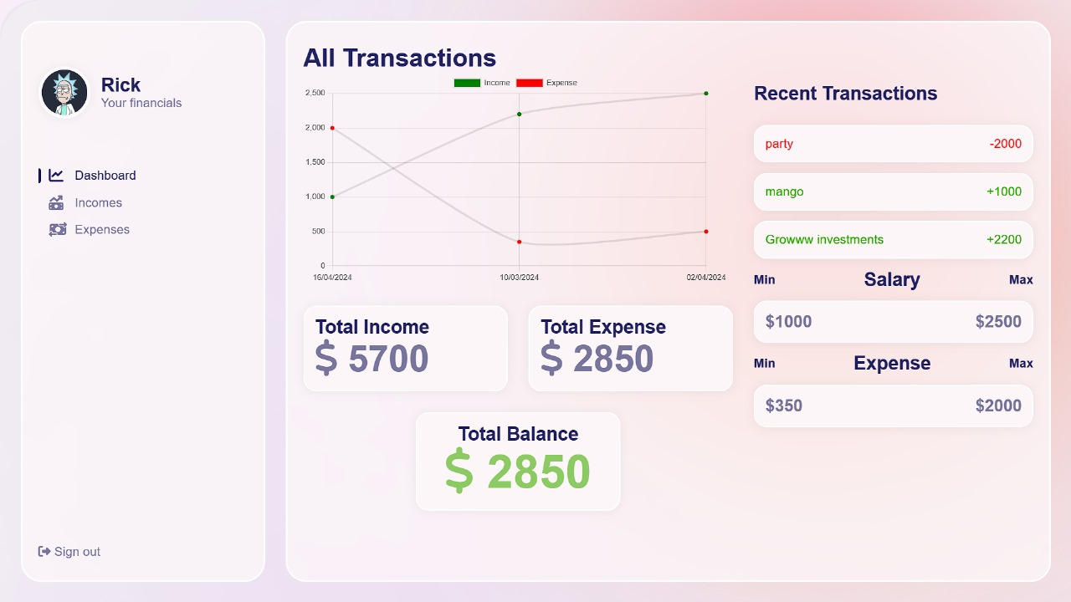

Dashboard

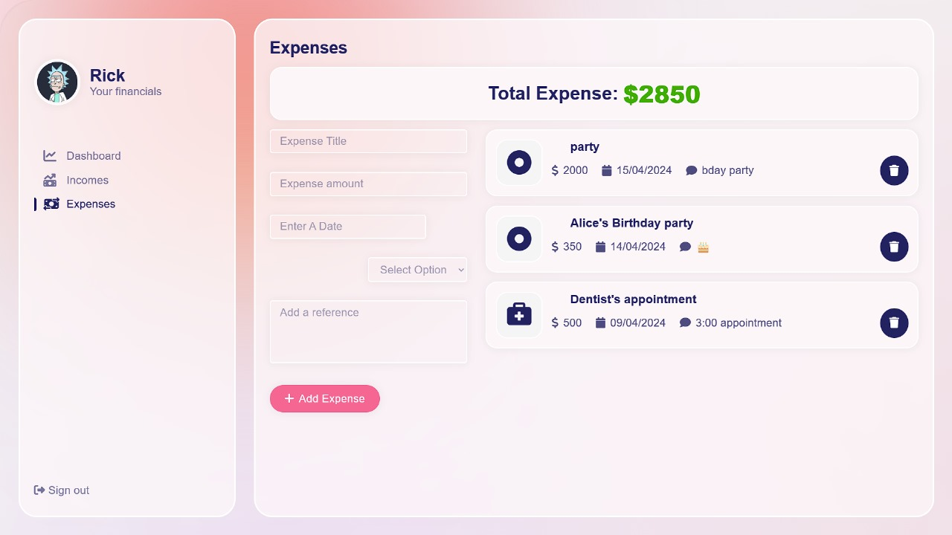

Expenses

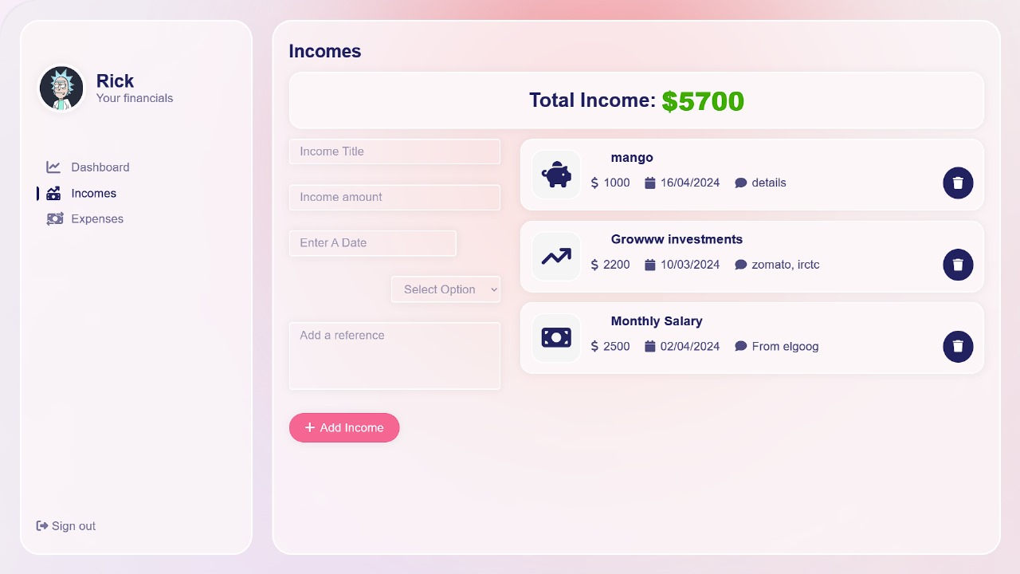

Income

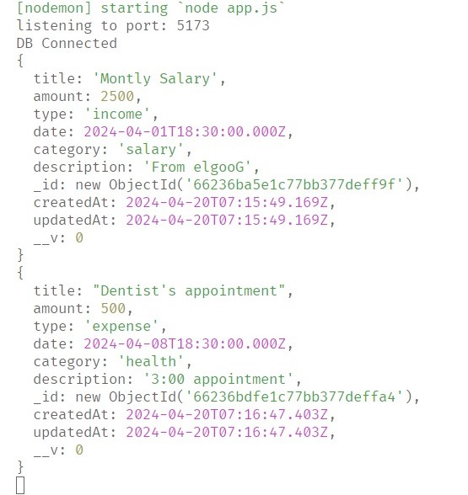

Database Input

**REQUIREMENTS ANALYSIS**

**Hardware Requirements:**

- Server:

- Processor: Multi-core CPU for handling concurrent requests.

- RAM: Minimum 8GB RAM for data processing.

- Storage: SSD storage for fast access to data.

- Network: Gigabit Ethernet for high-speed connectivity.

- Client Devices:

- Personal Computers: Compatible with modern web browsers.

- Mobile Devices: Support for iOS and Android platforms.

**Software Requirements:**

- Operating System: Windows 11.

- Web Server: Apache or Nginx.

- Database: MongoDB.

- Application Frameworks: React.js for frontend, Express.js for backend.

- Authentication: JSON Web Tokens (JWT) for secure authentication.

- Development Tools: Visual Studio Code or Sublime Text for code editing, Git and GitHub for version control.

**CONCLUSION**

In conclusion, our project represents a significant step towards empowering individuals to take control of their financial well-being. By providing a user-friendly platform with robust features for budgeting, expense tracking, and goal setting, we aim to address common challenges in personal finance management. Through seamless integration with financial institutions, advanced AI-driven insights, and a commitment to security and privacy, our platform offers users a comprehensive solution to navigate the complexities of modern finance.

With a focus on usability, scalability, and security, we strive to create an inclusive ecosystem where individuals of all backgrounds can access the tools and resources needed to achieve their financial goals. By fostering a supportive community and promoting financial literacy through gamification and educational initiatives, we aspire to not only improve financial outcomes but also instill confidence and empowerment in our users.

As we continue to innovate and evolve, we remain dedicated to our mission of elevating financial empowerment and promoting long-term financial stability for individuals worldwide. Together, we can build a brighter future where financial success is within reach for everyone.

**REFERENCES.**

Guan N, G. A. M. P. X. F. A.-J. H., 2022. Financial stress and depression in adults: A systematic review. *National Library of Medicine.*

Iman Dianat, P. A. M. A. J. M. A. K., 2019. User-centred web design, usability and user satisfaction: The case of online. *Applied Ergonomics,* Volume 81.

Sangwoon Lee, R. J. K., 2010. The effects of usability and web design attributes on user preference for e-commerce websites. *Computers in Industry,* 61(4), pp. 329-341.

Urvashi Tandon, R. K. A. N. S., 2015. Customer satisfaction using website functionality, perceived usability and perceived usefulness towards online shopping in India. *Information Development,* pp. 1657-1763.

## Books:

1. Design and Build Websites – Jon Duckett

2. A Smarter Way to Learn HTML, CSS, JavaScript

3. MongoDB: The Definitive Guide – Kristina Chodorow

## Websites:

1. <https://www.scaler.com/>

2. <https://www.codercoder.com/>

3. <https://www.freecodecamp.org/>

4. https://www.fonts.google.com/